Run the DesktopLauncher class in the desktop folder. DungeonDaredevil > dekstop > src > pjkck > dungeondaredevil > desktop > DesktopLauncher.java

The documentation is located in the Docs folder

I’m in boise

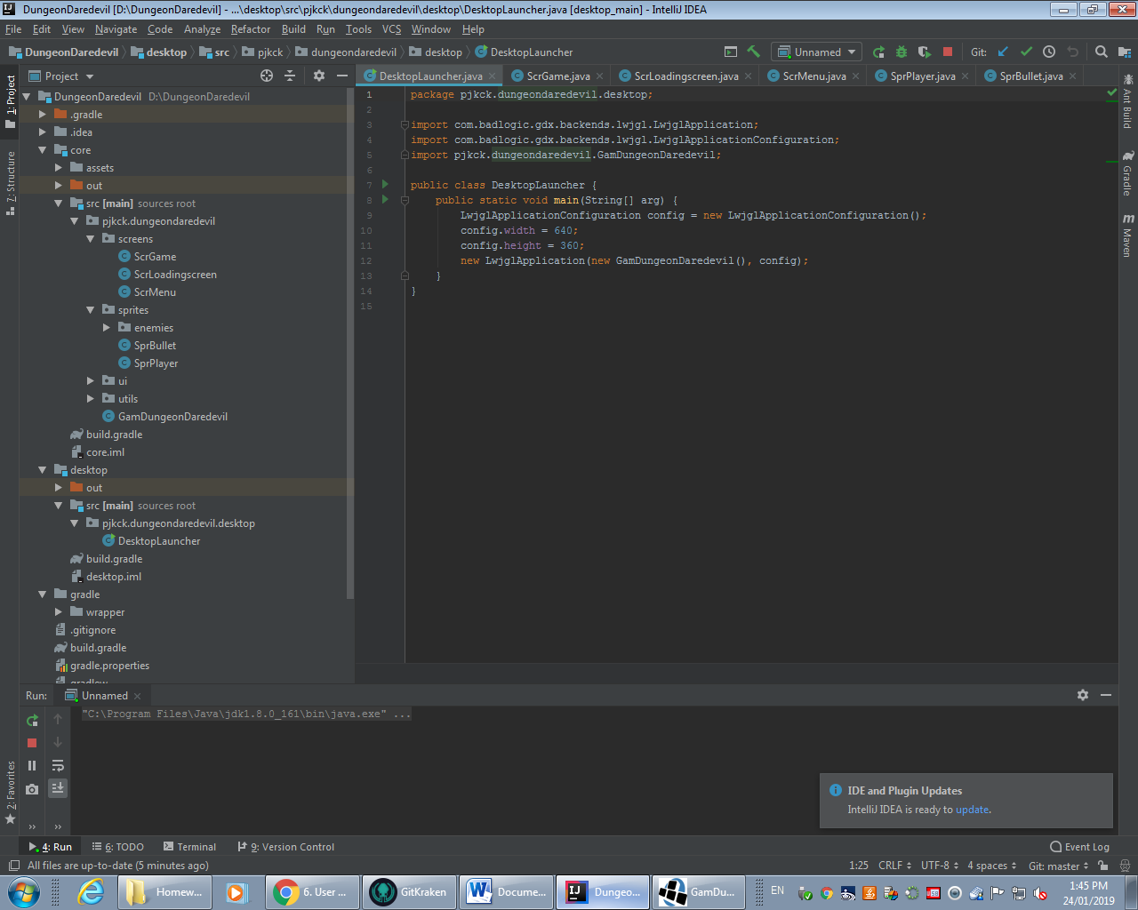

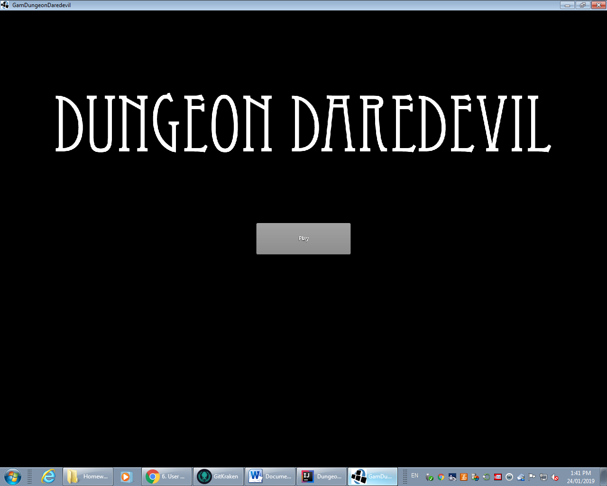

The Title Screen: Hit Play to play.

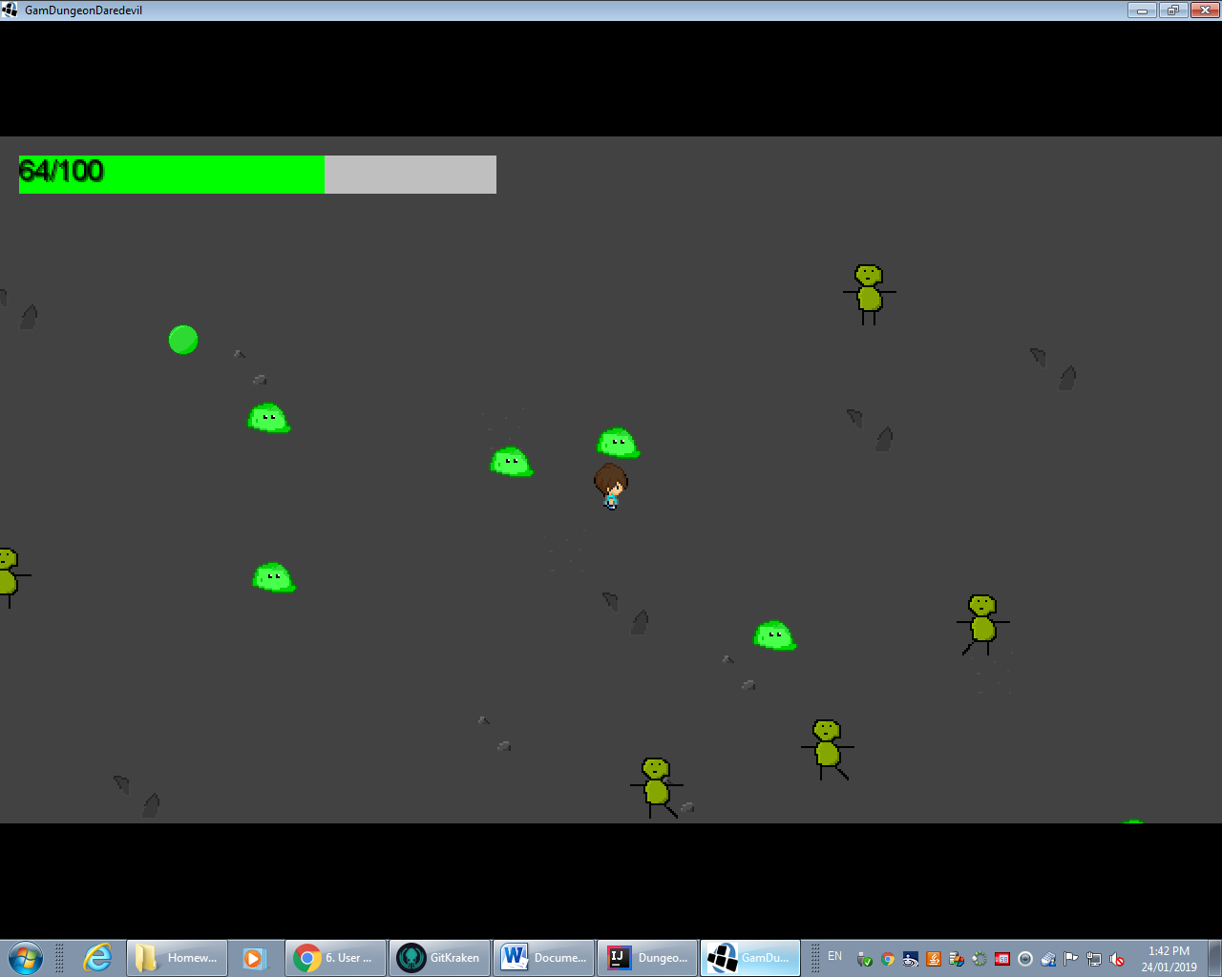

The Game Screen:

* Use WASD to move
* Use space to dash in the direction you’re facing
* Up and Down arrows to switch weapons
* Click to shoot the enemies to kill them
* When all the enemies are dead you win (if you count being stuck forever as winning)
* You lose health when you get hit by an enemy bullet
* If your health bar hits 0 HP you’ll die and be kicked to the title screen